**Bug Report**

|  |  |
| --- | --- |
| Defect ID |  |
| Build Name | Register_ac |
| Build ID | B01 |
| Release Name | Release1 |
| Module Name | Register |
| URL | <https://demo.opencart.com> |
| Test Case Name | Opencart_register_ invalid phone no |
| Test Data | Try all below invalid phone formats: 1) 11345 2) abcd |
| Found By | Priyanka |
| Test Environment | OS- Windows 10  Browser- Chrome |
| Status | New |
| Severity | Blocker |
| Priority | High |
| Assigned to | Dev lead |

**Description**

User is able to register an account by providing an invalid number

**Steps to reproduce**

1. Click on 'My Account' Drop menu  
2. Click on 'Register' option   
3. Enter new Account Details into all the Fields (First Name, Last Name ,E-Mail, Password, Password Confirm, Newsletter and Privacy Policy Fields)  
4. Enter invalid phone number into the Telephone Field - <Refer Test Data>  
5. Click on 'Continue' button

**Expected result**

Account should not be created, instead a proper warning message should be displayed

**Actual result**

Warning message is not getting display , instead an Account is getting created with the given invalid phone number

**Screen Shot**

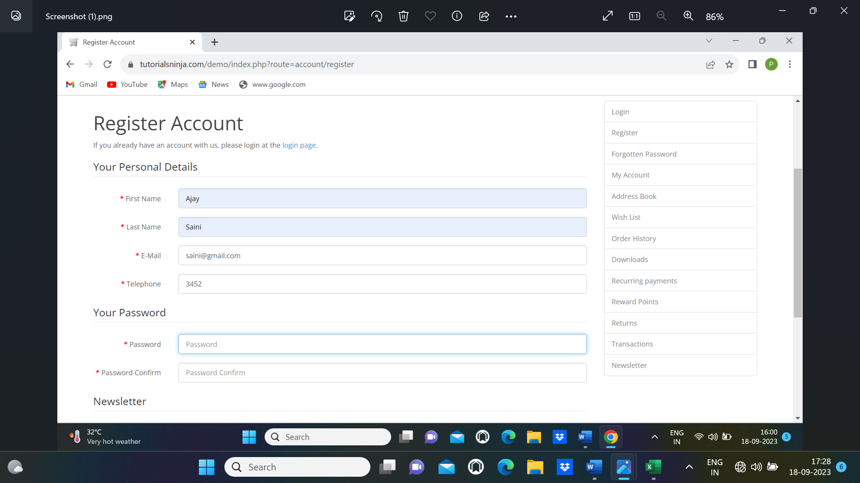

|  |  |  |
| --- | --- | --- |
| Submit | Clear | Cancel |